**LAB REPORT #7** Name: Owais Rao

**LOOPS** Roll No.:22L-7638

Class: BSEE-1A2

**Introduction:-**

Repetition statements are called loops, and are used to repeat the same code multiple times in succession. The number of repetitions is based on criteria defined in the loop structure, usually a true/false expression. C++ supports various types of loops like**for loop, while loop, do-while loop**, each has its own syntax, advantages, and usage.

**Objective:-**

* To be able to understand the working of loops.

**Procedure:-**

With the help of lab manual, I was able to write codes for given exercises. They are as follows with their outputs:-

**Exercise 1:-**

#include <iostream>

using namespace std;

void main()

{

//Program (a):

for (int count = 1; count <= 5; count++)

{

cout << count << "\n";

}

cout << endl;

//Program (b):

int count = 1;

while (count <= 5)

{

cout << count << "\n";

count++;

}

}

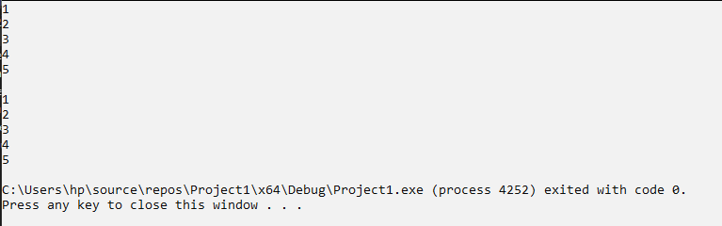

**Exercise 2:-**

#include <iostream>

using namespace std;

void main()

{

double N, a , sum = 0, b = 0, c = 0;

cout << "Enter integer: ";

cin >> N;

if (N >= 1)

{

for (a = 1; a <= N; a++)

{

b = a * a;

cout << b << endl;

sum += b;

}

cout << "Sum=" << sum << endl;

}

else

{

cout << "Invalid input." << endl;

}

}

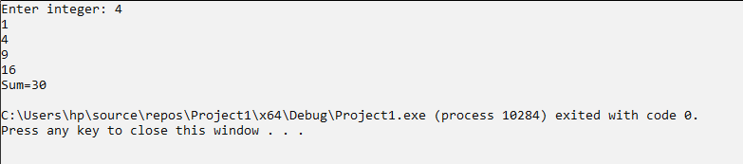

**Exercise 3:-**

#include <iostream>

using namespace std;

void main()

{

int spaces = 0, size = 0, start = 1;

cout << "Enter size of Triangle: ";

cin >> size;

cout << "Enter start value of Triangle: ";

cin >> start;

for (int j = 0; j < size; j++)

{

for (int i = 0; i < size - j; i++)

{

if (start < 10)

{

cout << start << " ";

start++;

}

else

{

start = 1;

cout << start << " ";

start++;

}

}

cout << endl;

for (int n = 0; n < j + 1; n++)

{

cout << " ";

}

}

cout << endl;

spaces++;

size--;

}

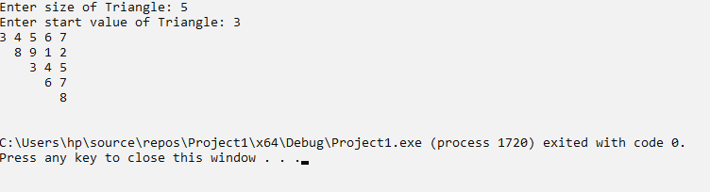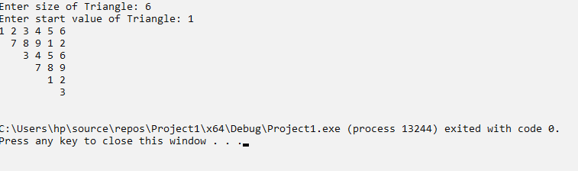

**Issues:-**

No issues were faced.

**Conclusion:-**

* I was able to understand the working of loops.

**Applications:-**

* Loop statements in C++ execute a certain block of the code or statement multiple times.
* Loops are mainly used to reduce the length of the code by executing the same function multiple times and to reduce the redundancy of the code.